**ATHBY - YEAR 12 ATAR HUMAN BIOLOGY**

**Task 3: Response to Infection ANSWER KEY**

**Task Weighting –** 7% **Task Type –** Response

Pre Task ____ / 5

Response ____ / 20

Total ____ / 25

1. Name the response type of the body to most viruses, and outline it in detail (10 marks)

|  |  |
| --- | --- |
|  | Marks |
| **Compulsory** | |
| Most viruses are responded to with a cellular response (1)  As the are mainly intercellular (1) | 2 |
| **Any** in **logical order** for 8 marks max.  Students should be responding with an annotated diagram. | |
| Pathogen ingested by macrophage or dendritic cell | 1 |
| Pathogen digested | 1 |
| Fragments presented to TH cells | 1 |
| Helper T cells secrete cytokines | 1 |
| Cytokines activate TK cells | 1 |
| Cytokines stimulate killer T cells to divide | 1 |
| TK cells hunt and destroy infected cells | 1 |
| Some TK cells go on to become TM cells | 1 |
| Cytokines activate B cell pathway | 1 |

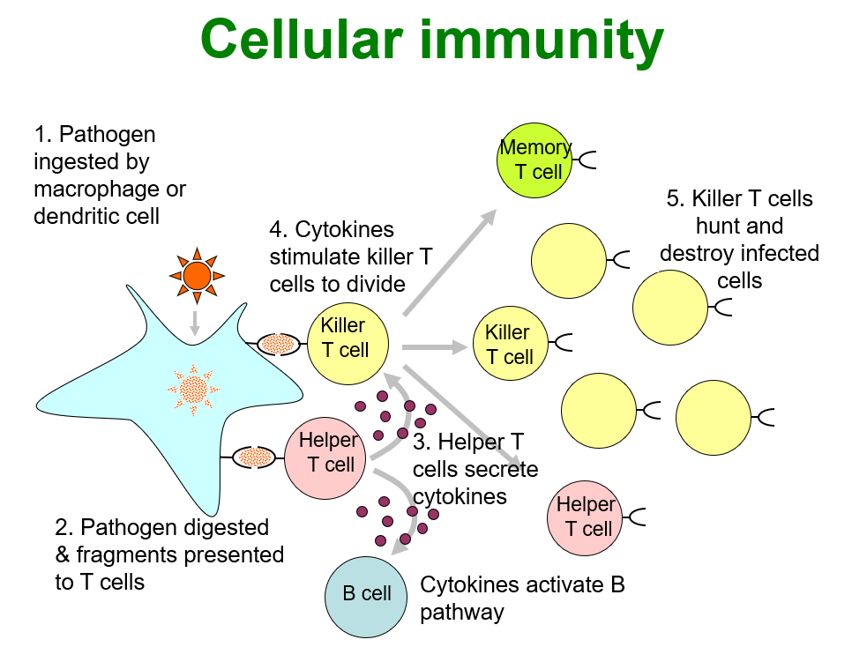

1. From the ‘**Reasons not to get vaccinated with the AstraZeneca COVID-19 Vaccine**’ list, choose a standard group [social, cultural, economic] and classify one of the given reasons for non-engagement with the Astra-Zeneca vaccination programme worldwide into your chosen group. Justify your classification. (2 marks)

|  |  |
| --- | --- |
| **NB: The reading list contains 6 medical reasons, and one social/cultural reason** | **Mark** |
| Social - *My friend or relative told me not to get vaccinated* (accept cultural for this reason as well) | 1 |
| Justification - Various | 1 |

1. Outline the procedure epidemiologists go through to evaluate the claims of some anti-vaccination groups that certain vaccines cause an increased rate of infertility in women (3 marks)

|  |  |
| --- | --- |
|  | **Mark** |
| Data driven | 1 |
| Vaccination records used to divide women of childbearing age in certain countries into groups based on vaccination received | 1 |
| Fertility rate calculated for each group | 1 |

1. From your reading of the Effectiveness and Safety article today, name the mechanism through which large populations can be protected. (1 mark)

Herd immunity (1)

1. Explain how lasting long term humoral and cell-mediated immunity is developed. (2 marks)

B memory cells are formed and circulate (1)

T memory cells are formed and circulate (1)

1. Outline the benefits of lasting immunity to a large population. (2 marks)

Mutation rates slow as infection rates decline (1)

Population productivity increase and/or health care costs decline as less people fall sick (1)